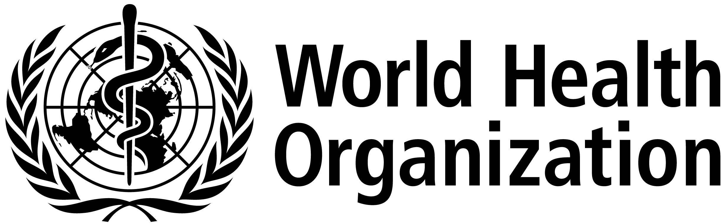

ISARIC/WHO Severe Acute Respiratory Infection Biological Sampling Study

INFORMATION SHEET FOR PATIENT
13th May 2013. Version 2.5.0
We are undertaking a research study involving people with severe acute respiratory infections, which is why we have approached you.
You are invited to take part in this study.
Before you decide it is important for you to understand why the research is being done and what it would involve for you. Please take time to read this information carefully. One of our team will go through the information with you. Please ask us if there is anything that is not clear or if you would like more information and time to decide. Your decision is completely voluntary. The decision you make will not affect your care or treatment in any way.
What is the study about?
Infectious diseases affect millions of people around the world every year. Most cases are mild, but some people become very unwell. There is a great deal that we do not understand about existing infections, and new infectious diseases continue to appear. This research study will gain important information about respiratory infections so we can try to find better ways to manage and treat them in the future.
What will happen if I take part in this study?
We will collect information and samples which are in addition to what would normally be collected for your medical care.
A blood sample will be taken now, together with a swab from your throat, a swab from any infected sites/sores, a sputum sample, urine sample and a stool sample or rectal swab.
We will take the same samples again over the next two weeks, every second day and then every week for as long as you are unwell up to a maximum of 100 days. We will also invite you to return to the hospital or clinic in 3 months and 6 months to have a blood sample taken. Each sample will take less than 15mls (3 teaspoons) of blood.
If any other samples are taken from you for regular care, and if there is leftover sample after the tests requested by your doctors are done, we will store the leftover to be tested.
What will happen to the samples and information?
We will use the blood samples to look at how the body fights the infection and how the treatments work in the body. We will also use the blood sample to analyse your DNA. We will examine your DNA together with DNA from many other people to try to find out what makes some people more susceptible to infection. Some of the tests may be done in different countries.
All information about you will be handled in confidence and only the people responsible for your care and for this study will know that you were a part of the study. We will review your medical records and keep limited information about you on a secure file. All information and samples will be labelled only with a number so that they cannot be directly linked to you personally. With your permission, we would also like to store your samples and use them for future ethically approved medical research. The data and samples collected during this study may be looked at by public health agencies.
Are there any benefits to taking part in this study?
There is no benefit to you personally. The information gained from this study may not be available in time to affect your care. Any results available while you are in hospital will be given to your treating doctor. The information we learn may help in caring for other patients in the future.
What are the risks of being in the study?
Being a part of this study means that more samples will be taken than are needed for normal care. Whenever possible these samples will be taken at the same time as regular samples to reduce the extra procedures. There is a risk of pain or irritation when samples are taken.
When DNA testing is done, there is a small chance that the results will show a genetic condition that could affect your future health. Since the tests will be conducted anonymously, no-one on the study team will know that such a result applies to you, and in any case there is usually considerable uncertainty about the implications of any research DNA test result for individual health. For these reasons we would not attempt to identify you or inform you of any results from DNA testing.
Who is responsible and what if something goes wrong?
[***insert sponsor and contact details***]
Can I request that I be withdrawn from the study at any point?
Yes, you can withdraw at anytime without giving a reason and without affecting your care. Any samples that have not already been analysed can be destroyed anytime you request it.
What if I have any problems or would like further information about the study?
[***insert details***]

